Uml

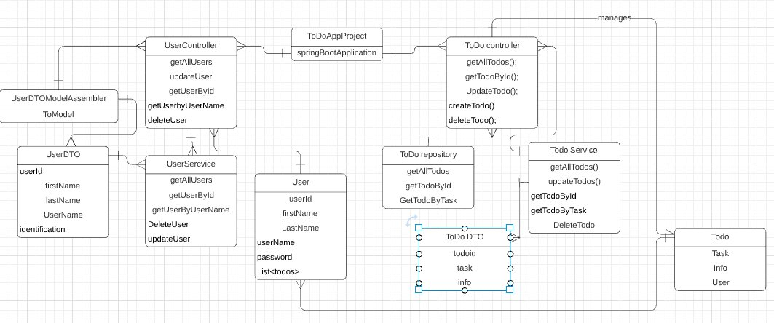

|  |  |  |  |  |  |  |
| --- | --- | --- | --- | --- | --- | --- |
| **risk​** | **statement​** | **response​** | **Objective​** | **Likelyhood​** | **impact​** | **risk level​** |
| **procrastination​** | Unwilling to work in favour of more leasure​ | provide motivation to conduct weork​ | Increase leasurly ambience i.e.music while working or implement the fear element of not completing it​ | unlikely​ | minimal​ | 2​ |
| **Injury​** | Eye or back strain​ | Increase movement while working from a stationary position​ | Add exercise breaks in between working sessions​ | rare​ | minimal​ | 1​ |
| **Git-hub issues​** | User encounters a merge conflict where git fails at the start or during a merge​ | Identify the cause of conflict​ | Attempt to resolve merge conflicts ​ | likely​ | Extreme​ | 20​ |
| **Testing issues​** | The tests either fail to run or pass when they should be failing​ | Fix maven​ | Ensure maven is up to date and that the testing package is included in the build​ | Almost certain​ | major​ | 9​ |
| **Lose all working files​** | Somehow manages to loose all working files ​ | Make regular backups and commits​ | If this somehow happens the day before its due, just cry​ | rare​ | (extremely)n severe​ | 5​ |
| **Stuck on adding a feature​** | Struggling on implementing on a feature or unable to pass unit tests for said feature​ | Debug and fix​ | Use the debugger on eclipse to see exactly what is going wrong or use google to look up solutions for​ | likely​ | minor​ | 8​ |

Risk matrix

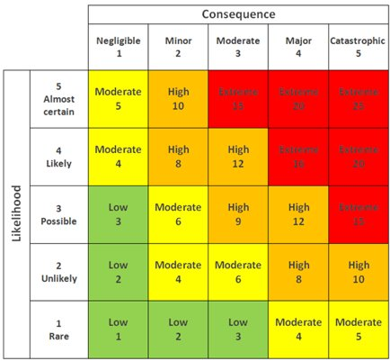

ERD

